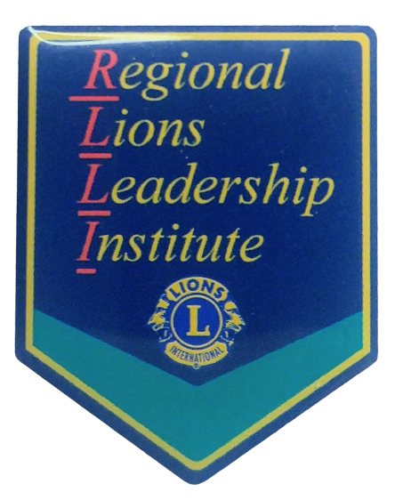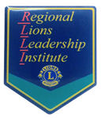
- PCC Linda Zaneski
- PDG Dick Sware
- PDG Tom Gregg
- PDG John Mallonee
- PDG Mike Schaeffer

Cost - $195 Per Lion
Meals & Lodging Included
PA Lions State Office, Harrisburg
RLLI
Contact Your District Governor
Or
PDG Bill Grager
bilbomzk@gmail.com
SUBJECTS
- Lions Fundamentals
- Team Work
- Diversity
- Public Speaking
- Time Management
- Personal Mission Statement
- Member Motivation
- Goal Setting
INSTRUCTORS
March 5-7, 2027

REGIONAL LIONS LEADERSHIP INSTITUTE
Sign Up Today – Space is Limited!

